Product | - Product Shot | Description | Product Information
2910 | 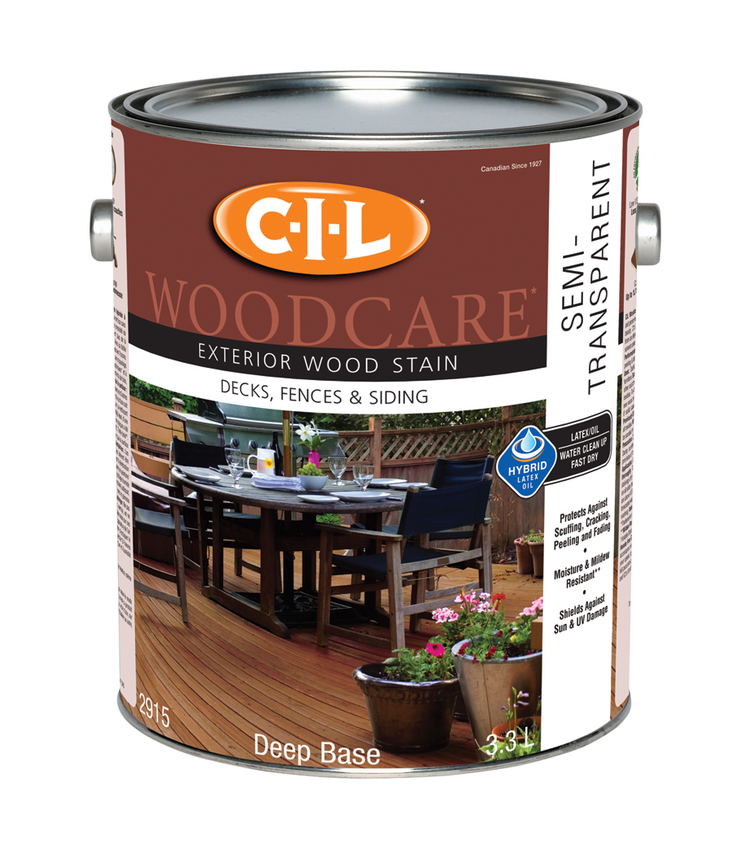 | CIL WOODCARE EXTERIOR SEMI-TRANSPARENT  with advanced acrylic / alkyd hybrid technology protects & preserves the grain of the wood while adding colour to the surface without blocking its natural beauty. | • HYBRID TECHNOLOGY - penetrates wood like an alkyd stain combined with easy soap and water clean up of a latex stain.  • Penetrates wood, repels water and resists moisture.  • Protects and enhances the beauty of the wood without concealing the grain.  • Superior protection against cracking.  • Easy to apply.  • Superior protection against bad weather, scuffing, blistering, and peeling.  • Penetrates wood, block sun’s UV rays and repel water.  • Contains fungicide which resists mildew.  • Low VOC* / Low Solvents.  *Volatile Organic Compounds. Less than 250 grams/litre.  • Ideal for vertical and horizontal surfaces: decks, fences, wood siding, soffits, wood shakes and shingles, doors or outdoor furniture.  • Ideal for new or bare wood including cedar, pine and spruce. Surfaces previously coated with semi-transparent stains that were exposed for more than one year.
3010 | 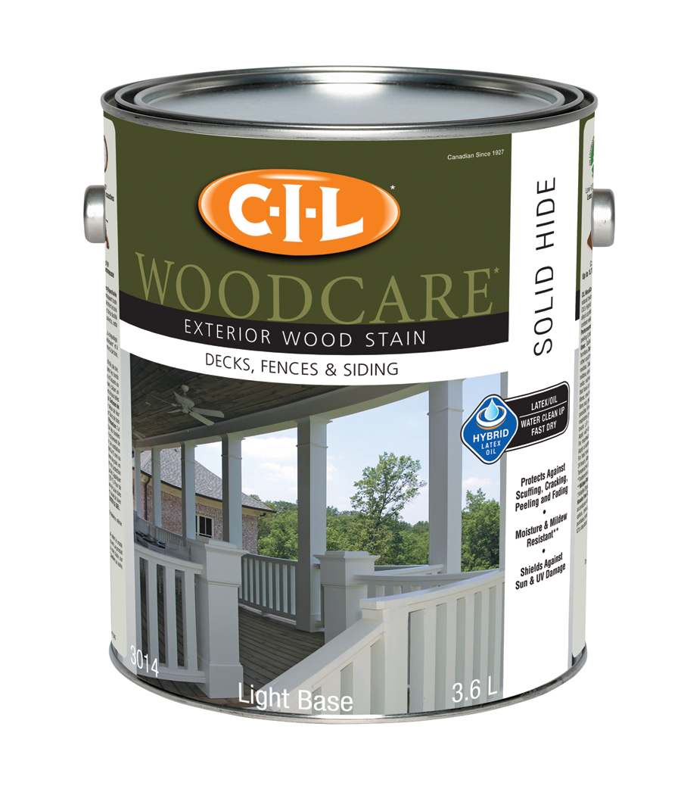 | CIL WOODCARE  SOLID STAIN  with advanced acrylic/natural oil hybrid technology thoroughly protects and preserves the natural texture of the wood while completely colouring the surface. | • HYBRID TECHNOLOGY - Water-based 100% acrylic latex enriched with natural oils.  • Easy to apply.  • Water-based microporous product allows wood to breathe.  • Protection against bad weather, blistering, and peeling.  • Easy water clean up and fast dry.  • Penetrates wood, block sun’s UV rays.  • Excellent hiding power.  • Contains fungicide which resists mildew.  • Low VOC* / Low Solvents.  *Volatile Organic Compounds. Less than 250 grams/litre.  • Ideal for vertical and horizontal surfaces: decks, fences, wood siding, soffits, wood shakes and shingles, doors or outdoor furniture.  • Ideal for new or bare wood including cedar, pine and spruce. Surfaces previously stained that were exposed for more than one year.

