Product | - Product Shot | Description | Product Information
9450 | 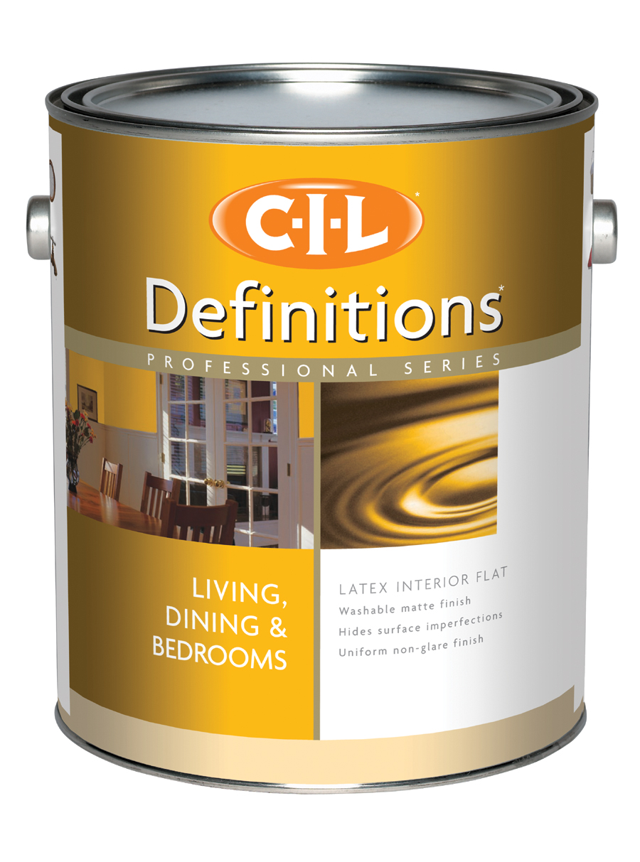 | CIL Definitions Latex Interior Flat | Flat sheen provides an elegant finish  Hides minor surface imperfections.  Easy to apply  Good touch up  Easy soap and water clean up
9490 | 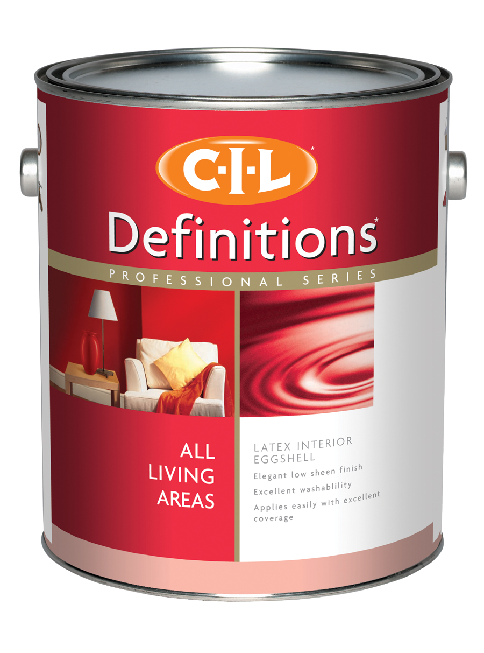 | CIL Definitions Latex Interior Eggshell | Low sheen eggshell finish  Durable and washable  Good touch up  High-hiding  Spatter resistant  Easy clean up with soap and water
9630 | 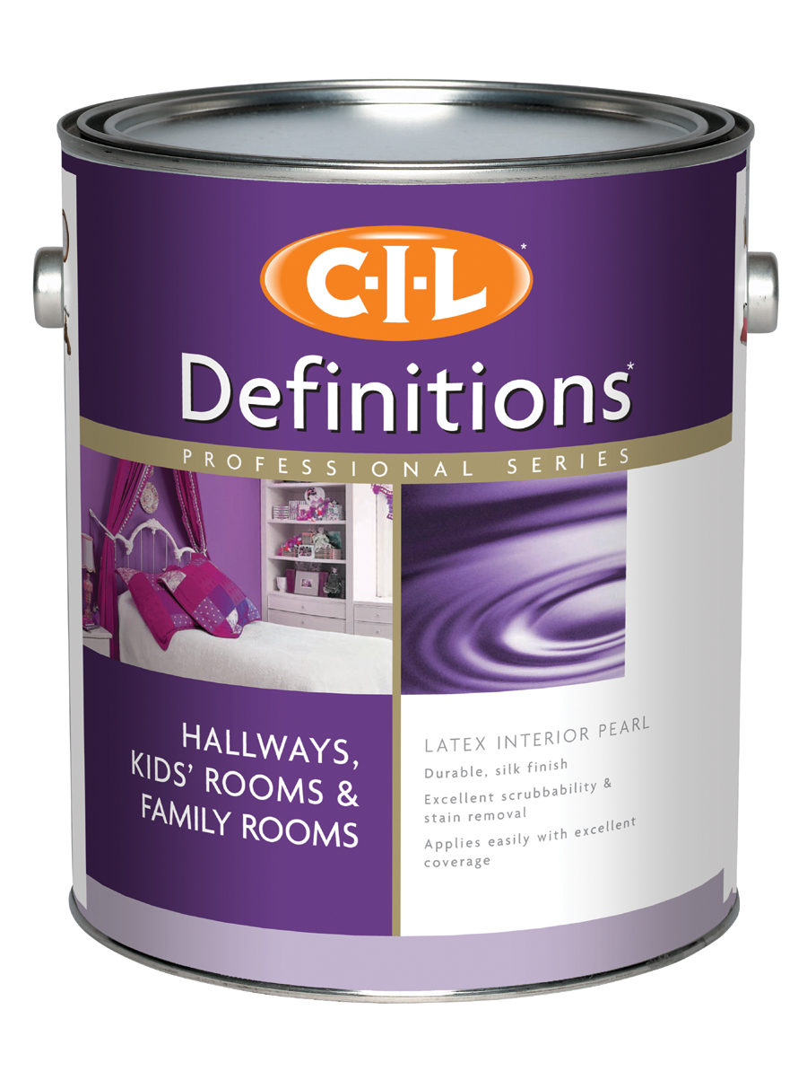 | CIL Definitions Latex Interior Pearl | Mid sheen finish is versatile enough for most applications  Durable and scrubbable  Easy to apply for professional results  High-hiding  Spatter resistant
9480 | 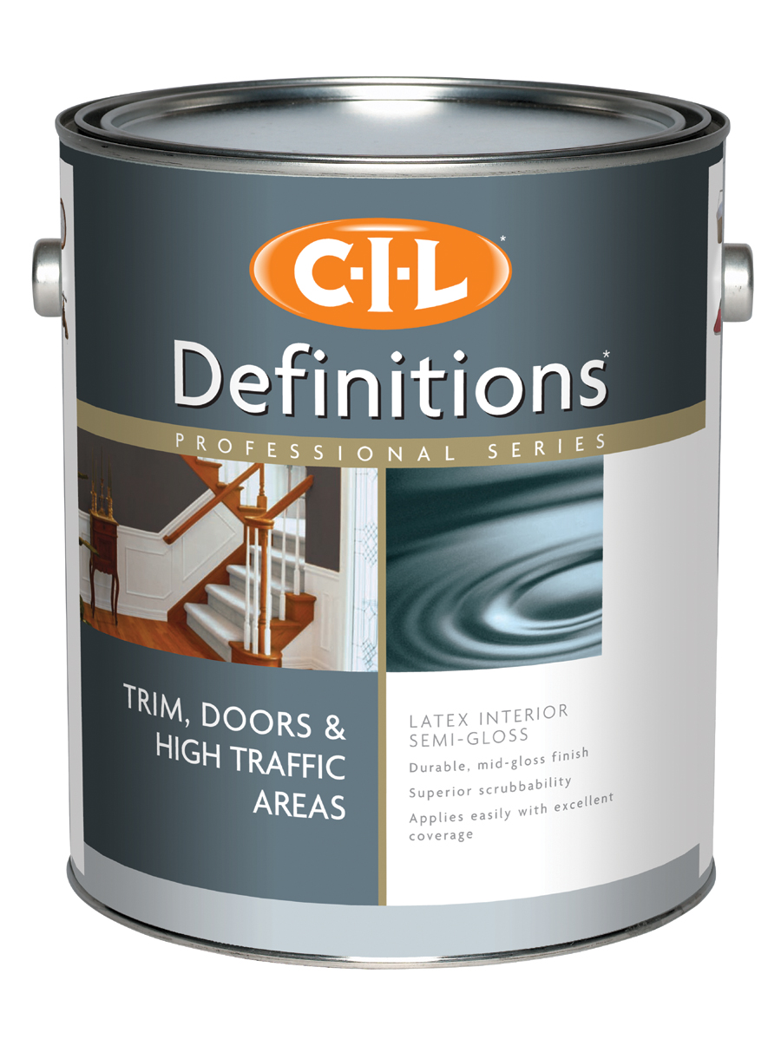 | CIL Definitions Latex Interior Semi-Gloss | Mid sheen finish is great for high traffic areas  Durable and scrubbable  High-hiding  Spatter resistant

SKU | - Product Shot | Description | Media Copy Points
9435 | 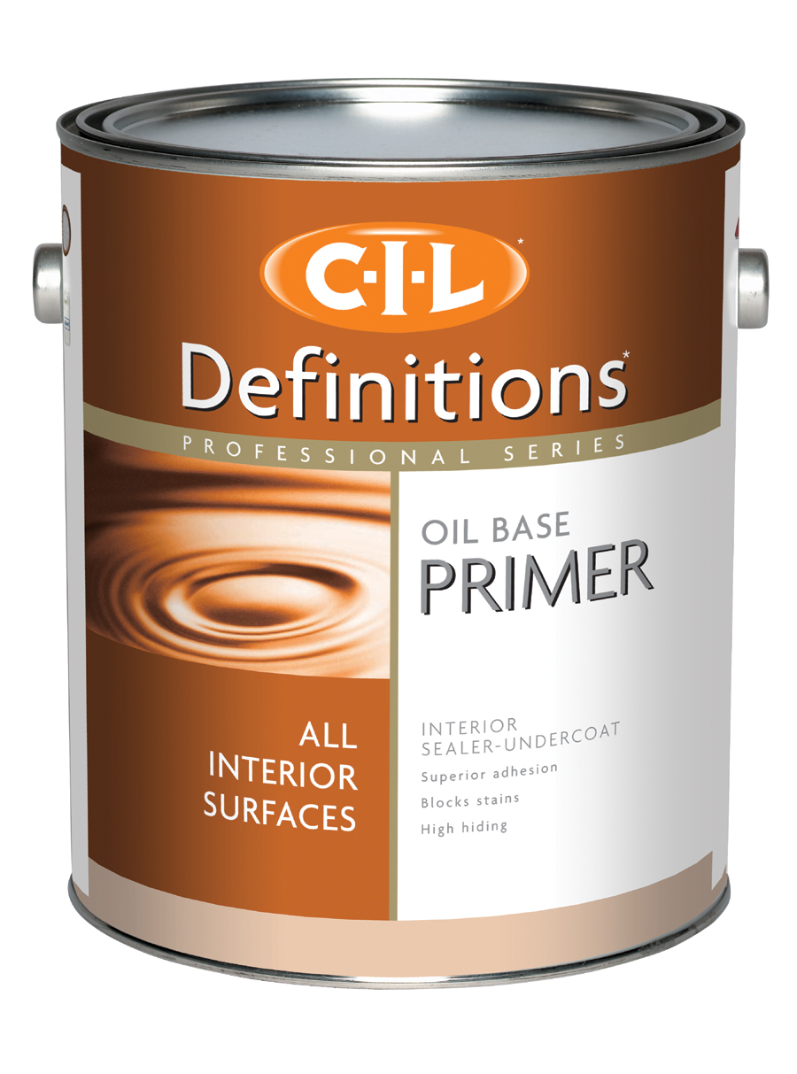 | CIL Definitions Oil Base Primer  Interior Sealer-Undercoat | Excellent sealer-undercoat with super adhesion  Provides good hiding & blocks stains  Low odour solvent  Easy to sand  Can be top coated with alkyd or latex
9531 | 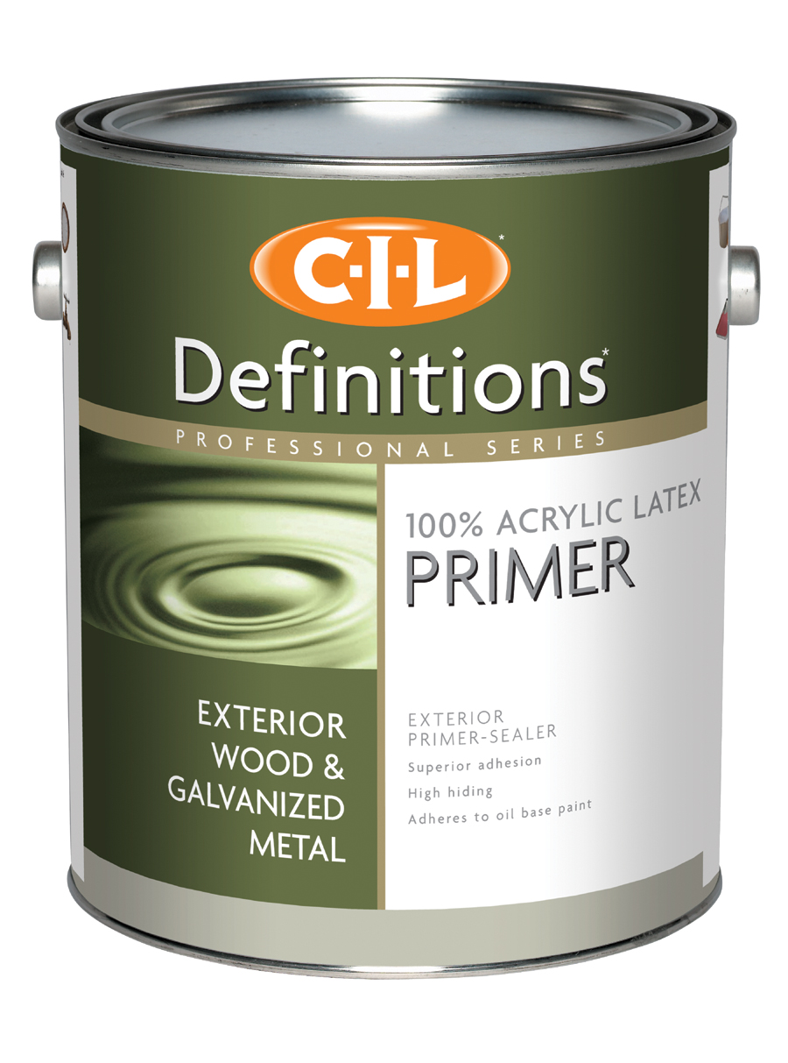 | CIL Definitions 100% Acrylic Latex Exterior Primer-Sealer | Good sealing for a uniform topcoat finish  100% acrylic can be applied over glossy and oil-based surfaces  Primed wood can be top coated with latex or alkyd coating  Primed metal can be top coated with latex coating only  Easy soap and water clean up
9421 | 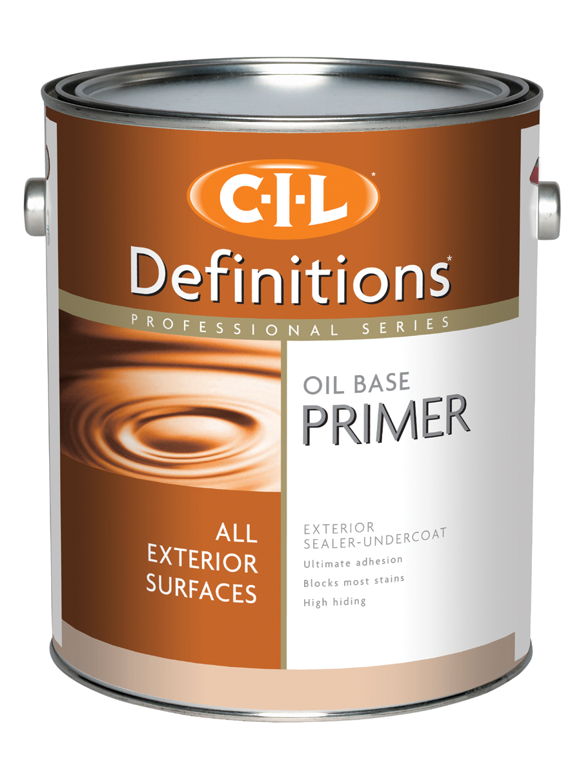 | CIL Definitions Oil Base Primer  Exterior Sealer-Undercoat | Primes and seals new and unpainted wood.  Seals previously painted surfaces for a uniform and consistent finish  Excellent hiding & blocks most stains.  Ultimate adhesion & may be top coated with alkyd or latex products.
19410 | 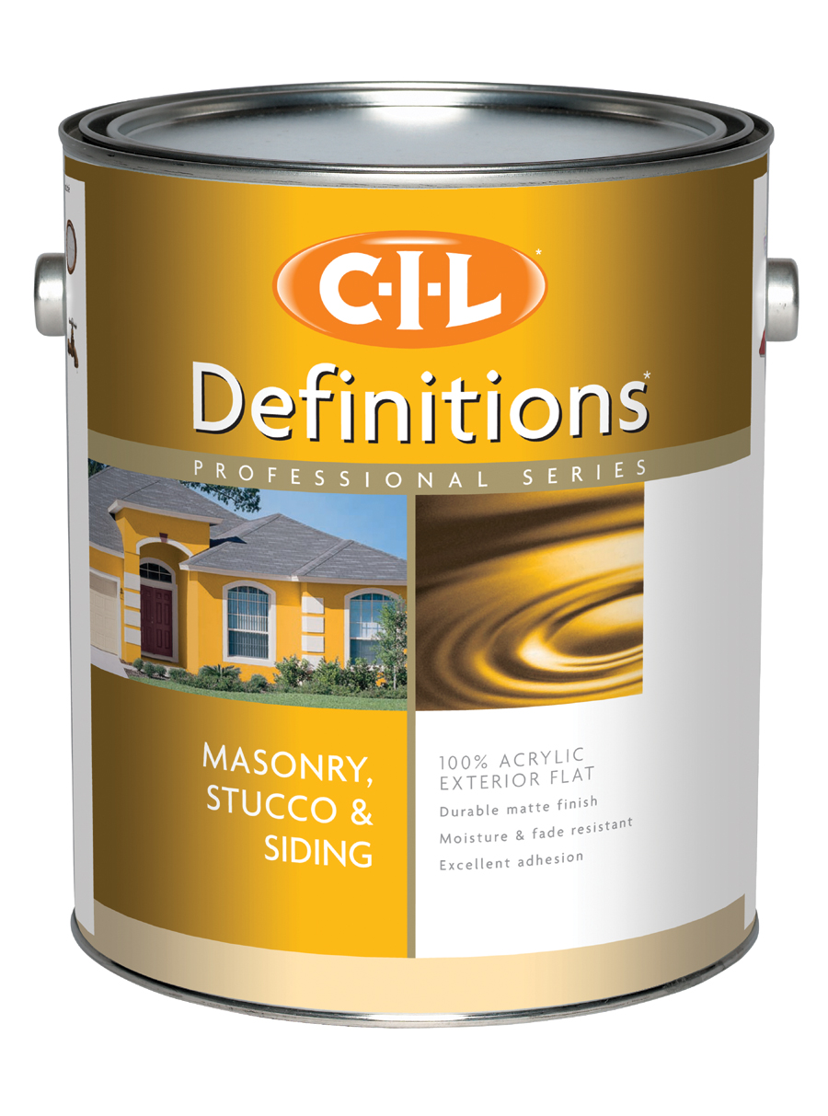 | CIL Definitions 100% Acrylic  Exterior Flat | 100% acrylic can be applied over glossy and oil-based surfaces.  Subtle matte sheen eliminates glare and hides minor imperfections.  High-hiding saves time by using less coats.  Moisture & fade resistant
19430 | 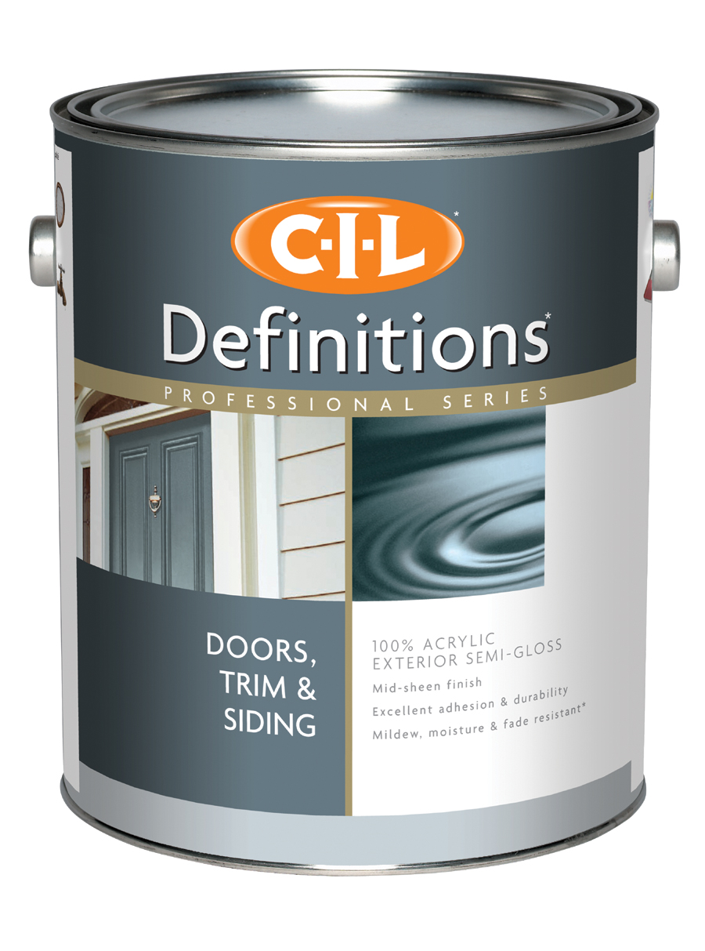 | CIL Definitions 100% Acrylic  Exterior Semi-Gloss | Mid sheen finish for excellent washability.  High hiding saves time by using fewer coats.  Mildew, moisture & fade resistant  Durable and tough  Easy to apply
19440 | 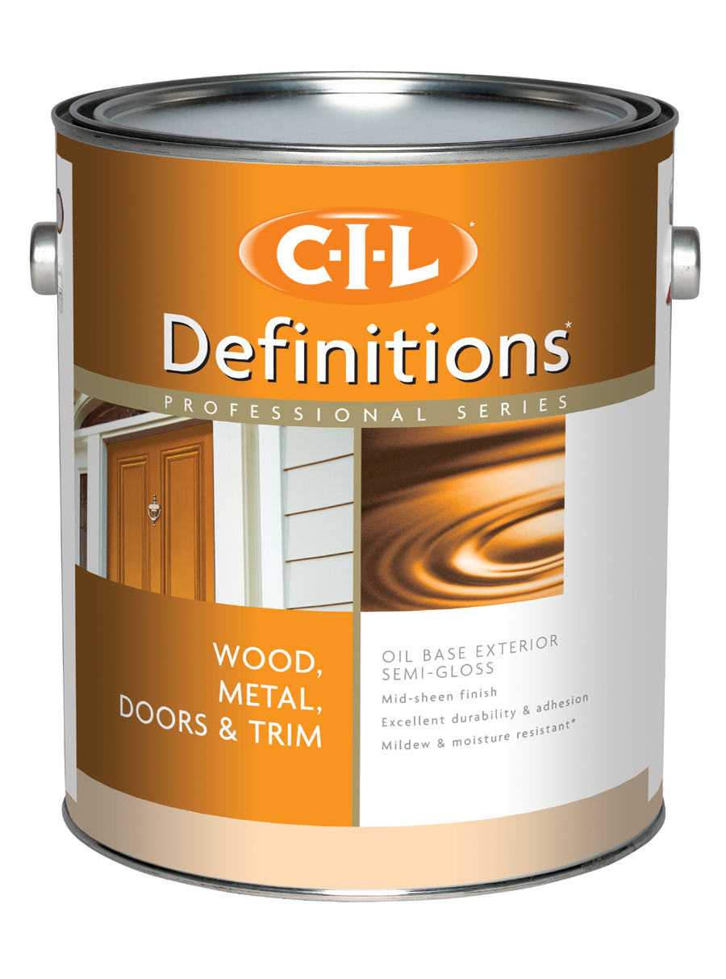 | CIL Definitions Oil Base Exterior Semi-Gloss | Mid sheen finish has excellent washability  High quality alkyd provides excellent adhesion  High hiding  Formulated with fungicide to resist mildew  Contains low odour solvents

